6-2 Project: Network Modification Brief

Blake Merry
Southern New Hampshire University
CYB-210 Programming Language
Prof. Jamilah Telon
April 10, 2026

Network traffic in this setup was segmented by using VLANs to separate different types of devices and communication into their own spaces. Instead of everything sharing the same network, each group was assigned to a specific VLAN based on its purpose. The Internal office computers remained on VLAN 50, labeled as “Data”, while the guest wireless network was placed on VLAN 70 and the camera system on VLAN 80. Even though everything is connected through the same physical switch, VLANs allow the network to act like these are separate environments. This helps reduce unnecessary traffic and keeps devices from interacting with systems they shouldn’t be able to reach.
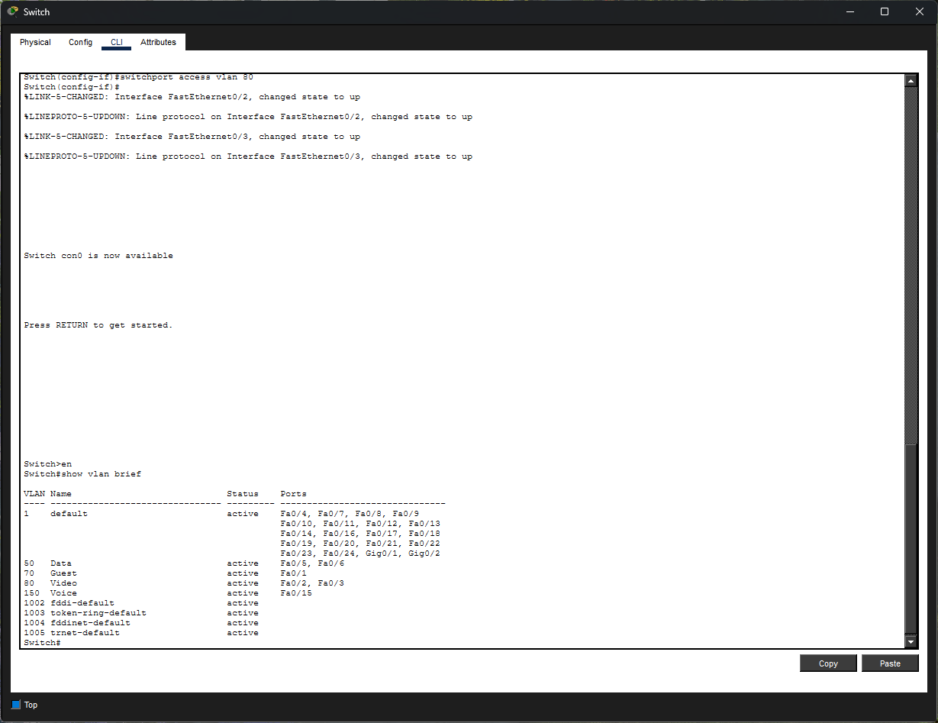
The guest wireless network was designed to be open and easy to access but also isolated from the rest of the network. Since this network is intended for public use, it introduces more risk than internal systems. By placing it on VLAN 70, guest devices are prevented from accessing internal office resources on VLAN 50. This king of separation is important because it limits what a potentially unsafe device can do. In testing, this was confirmed by attempting to ping devices on the data and video networks from a guest device, which failed. That shows that traffic is not being routed between VLANs, and that the segmentation is working as intended.
The video network was handled in a similar way. The cameras were placed on VLAN 80 so that their traffic would remain separate from both guest users and internal systems. Cameras tend to run continuously and can generate a steady stream of data, so separating them helps avoid unnecessary load on the main data network. It also adds a layer of protection by making sure that guest devices cannot access or interfere with the camera system. Each camera was given a static IP address within the 192.168.80.0/24 network, which makes sense since these devices are fixed and should always be reachable at the same address.
Overall, this setup shows how VLANs can be used to control how traffic moves through a network. Each VLAN has a clear purpose, and communication between them is restricted. Guest users can connect to Wi-Fi and receive an IP address, but they can’t reach internal computers or cameras. At the same time, the cameras operate independently without exposing their data to other parts of the network. Instead of allowing everything to talk freely, the network is designed with boundaries that match how each part is supposed to function.
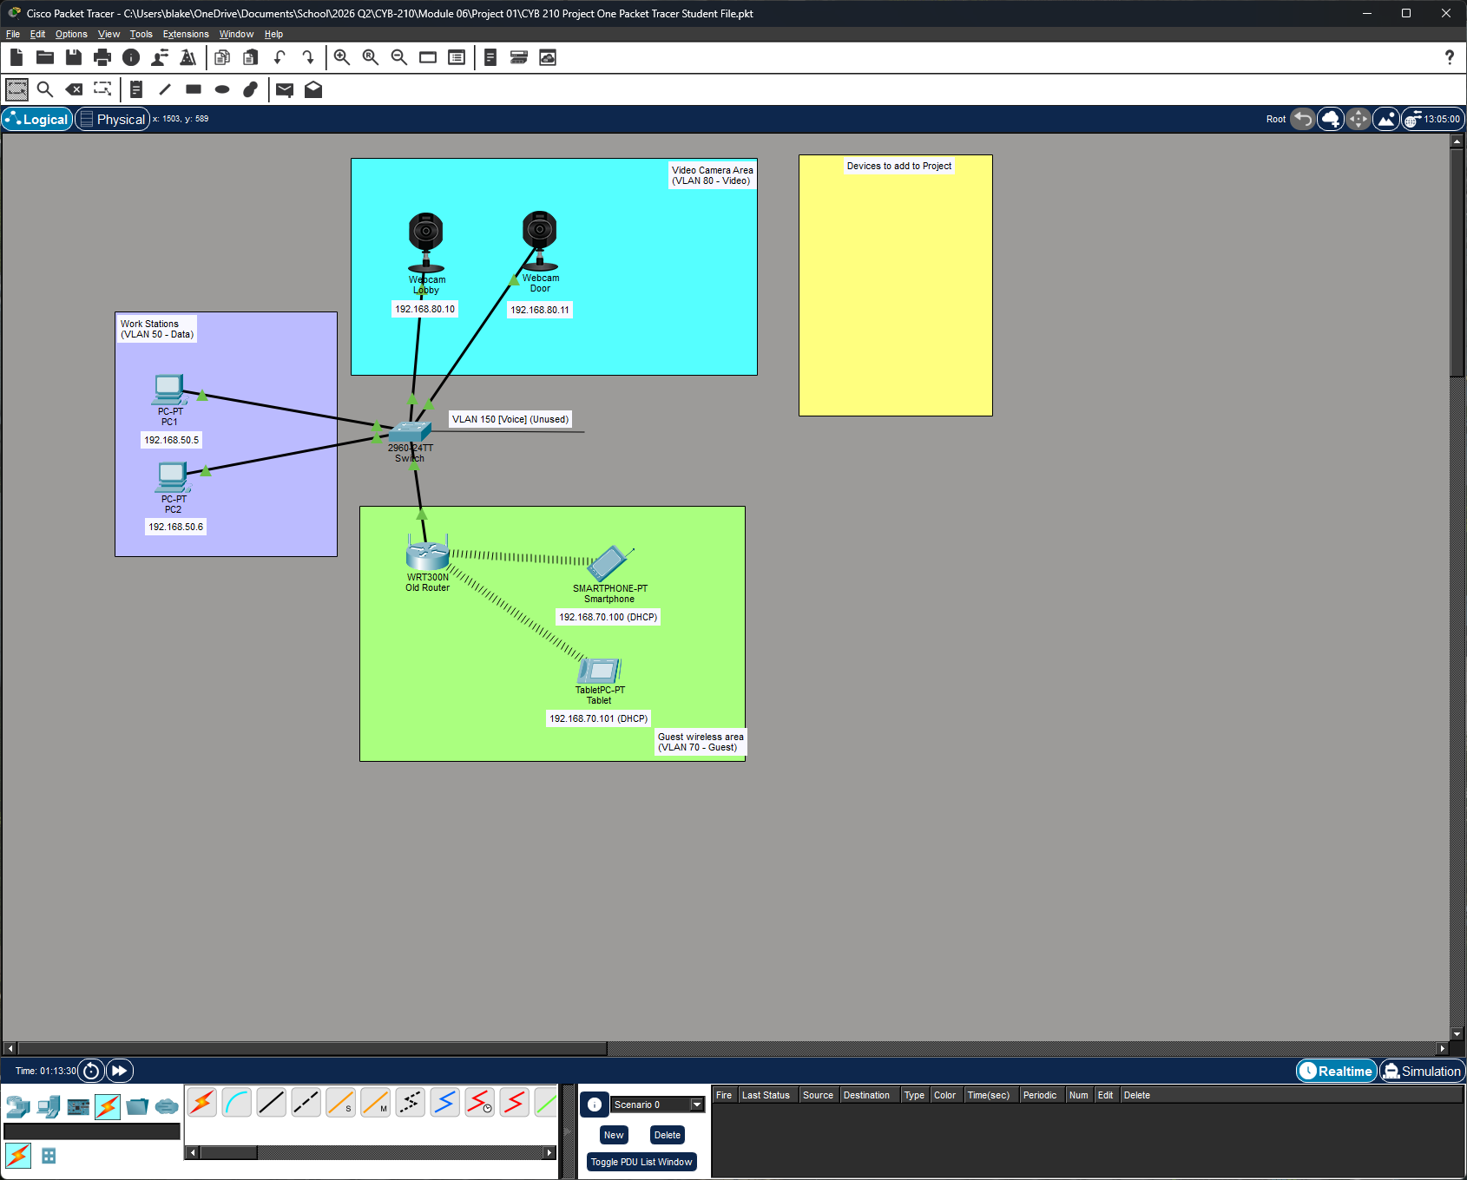
Scalability was mainly considered in how the guest wireless network was configured. The DHCP range starts at 192.168.70.100, which leaves room for reserved addresses if needed. The pool was sized to support about 70 users, which matches the expected number of guests in the scenario. Since guest devices are only connected for short periods of time, DHCP makes it easy to reuse IP addresses as people come and go. This avoids wasting addresses while still making sure there are enough available during busy times.
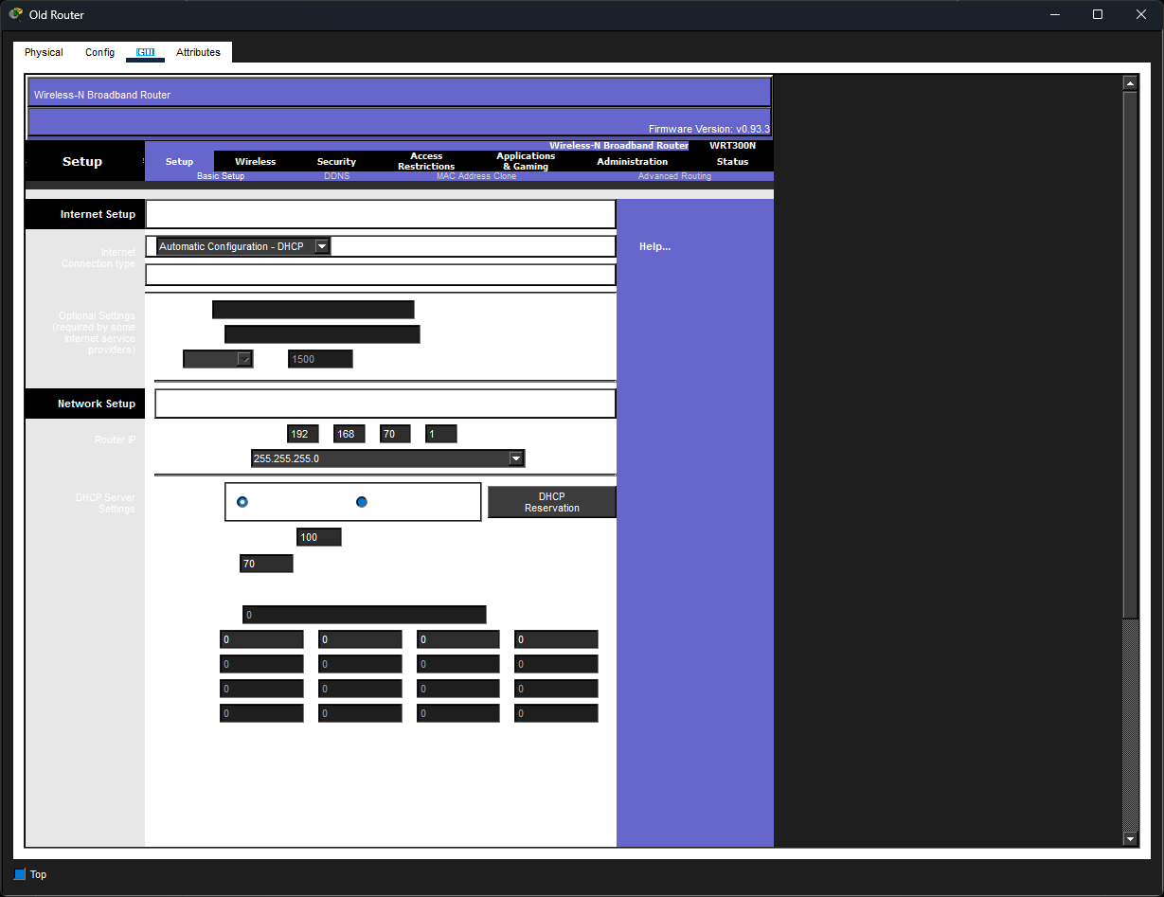
Using DHCP also keeps things simple from a management perspective. A guest network needs to handle constantly changing sets of devices, so manually assigning Ips wouldn’t make sense. DHCP handles that automatically, which makes the network easier to maintain and more flexible. The network is also intentionally open and unencrypted, which makes it easier for users to connect quickly. Instead of relying on authentication, security is handled through VLAN segmentation, which keeps guest traffic separate from everything else.
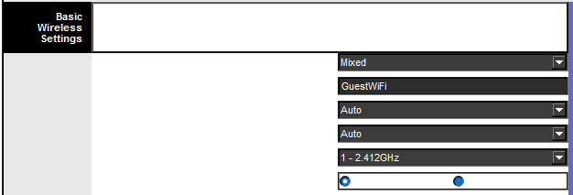
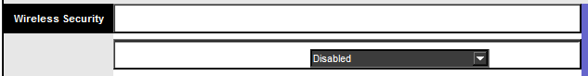
In the end, the network design balances accessibility with control. Guest users can connect easily, but they are limited to their own network. Cameras can operate consistently without interfering with other traffic. By combining VLAN segmentation with a properly sized DHCP pool, the network can support current needs while still allowing room for some growth.

